CS 188 Sp07 – Week 5 – Logic by Nuttapong Chentanez

Knowledge Bases
- Set of sentences in a formal language

Declarative Approach in building an agent
- We Tell what it needs to know, put in KB
- It Ask what it should do, by inference proceduce
- Put new observation into KB
- In contrast to procedural approach
- Wumpus world example

Model
- “Possible World”
- All possible truth assignments

Entailment
- α |= β
- β is true in all model where α is true

Inference Procedures
- Generate sentences from existing KB
- In this class, refer to the process of checking if a sentence is entailed

Soundness
- Does not make thing up. Sentence generate is entailed.

Completeness
- Generate all sentence that entailed. Can be more.

Propositional logic

Atomic sentence
- Stand for a proposition that is either true or false, represented by a single symbol

Literal
- Positive or Negative of atomic sentences

Logical Connectives & Complex Sentences
- (¬,~), ∧, ∨, ⇒, ⇔
- Sentences constructed from simpler sentences using logical connectives

Truth Table
- Specify truth value of complex sentences for all possible assignments of truth value of atomic sentences

Inference
- Ask if KB |= α, for some α

Simple algorithm for inference
- Enumerate all possible assignment of truth value and check

Equivalence, Validity and Satisfiability
- Equivalence – P and Q are equivalent iff P |= Q and Q |= P
- Validity – tautologies, true in all model
- Satisfiability – NP complete to check
- α |= β iff α ^ ¬β is not satisfiable
- Leads to algorithm for inference!

Logical equivalence
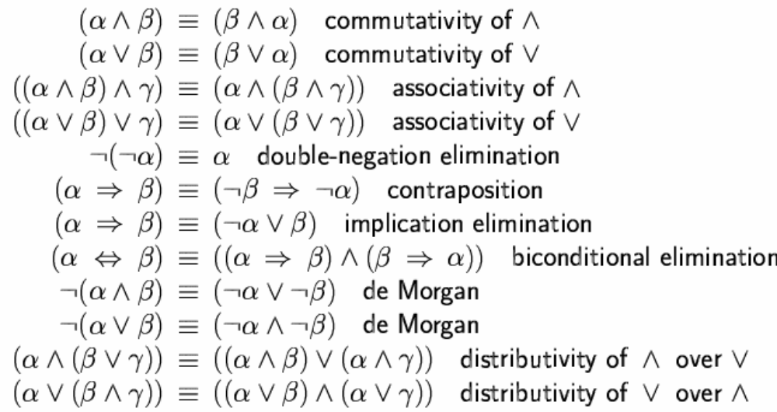

Reasoning Patterns
- Modus Ponens
α ⇒ β, α
-----------------
β
- And elimination
α ^ β
------
α

Monotonicity of logic
- if KB |= α then KB ^ β |= α
- This is the reason that agent based on KB works at all.
- The conclusion of the rule must follow regardless of what else in the knowledge base.
- Additional knowledge will not invalidate α already inferred

Propositional Logic Inference algorithms

Conjunctive Normal Form
- Conjunction of clauses, which are disjunctions of literal
- Any sentences can be reduced to CNF
- Hard for human to read, but easy for computer

k-CNF
- CNF where each clauses consist of exactly k literals
- Can convert any CNF to 3-CNF, by introducing variable

Resolution Algorithm
- To show KB |= α, show that (KB ^ ¬α) is unsatisfiable
- The only rule you really need, which was quite a surprise for me
l₁ ∨ …∨ l_{k}, m₁∨…..∨ m_{n}
---------------------------------------
l₁∨ …∨ l_{i-1} ∨ l_{i+1} ∨…. ∨ l_{k} ∨ m₁∨ …∨ m_{j-1} ∨ m_{j+1} ∨…. ∨ m_{k}

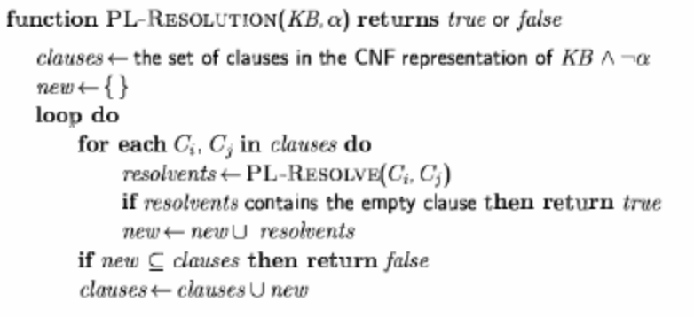
Apply the rule until either:
1. No new clauses can be generated, KB does not entail α
2. Create empty clause, KB entails α why? Can only happen from resolving p ^ ~p

- Need to remove duplicates literals
- Discard those with A ∨ ~A ∨ … , because always true

DPLL Algorithm

Improvements over truth table enumeration, by backtracking and pruning
Heuristics
1. Early termination
A clause is true if any literal is true.
Eg. (A ∨ B) ^ (A ∨ C), if A is true, need not care about B, C

A sentence is false if any clause is false.
Eg. (A ∨ B) ^ ….., if both A, B are false, need not care about others

2. Pure symbol heuristic
Pure symbol: always appears with the same "sign" in all clauses.
Make a pure symbol literal true.
e.g., In the three clauses (A ∨ ~B), (~B ∨ ~C), (C ∨ A), A and B are pure, C is
impure.

3. Unit clause heuristic
Unit clause: only one literal in the clause
The only literal in a unit clause must be true.
When does it show up?
Unit clause show up when all literals but one in a clause are assigned false

First Order Logic

-Propositional Logic assumes world contains facts

-FOL assume world contains
Objects – people, houses, numbers, colors, ..
Relations – Set of tuple, red, round, prime, brother of, …
Functions – relation for which there is one “value” for an input eg. father of

Domain
- Set of objects the universe contains

Symbols
- Constant symbol, stands for object eg. John, Crown,
- Predicate symbol, stands for relation, eg. OnHead
- Function symbol, LeftLeg

Syntax of FOL
- Term, logical expression that refers to an object, eg. John, LeftLeg(John)
- Atomic sentences, states fact eg. Brother(John, Richard), Married(Father(Richard), Mother(John))
- Complex sentences, use logical connectives from sentences
Eg. ~King(Richard) ⇒ King(John)
- Universal quantifier (∀), Existential quantifier (∃), make statements about all or some of objects
Eg. “There is someone who is loved by everyone”, ∃ y ∀ x [Love(x, y)]
- Equality, makes statement that two terms refer to the same objects
Eg. Richard has two brothers
∃x, ∃y [ Brother(x, Richard) ^ Brother(y, Richard) ^ ~(x = y) ]

Exercises

Propositional logic

1. Inference
- “If the unicorn is mythical, then it is immortal, but if it is not mythical, then it is a mortal mammal. If the unicorn is either immortal or a mammal, then it is horned. The unicorn is magical if it is horned.”
- Can you prove it’s mythical? Magical? Horned?
Solution:
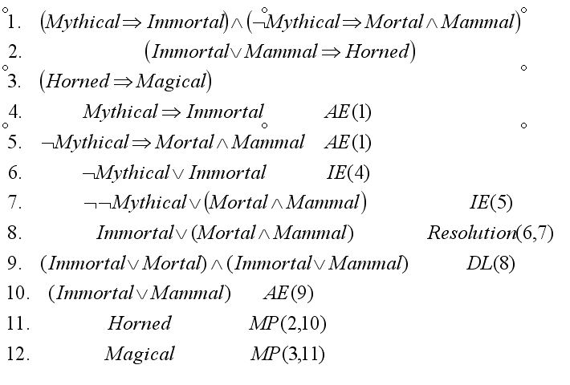

2. Convert to ~( (a ⇔ b) ∨ c) to CNF

Solution
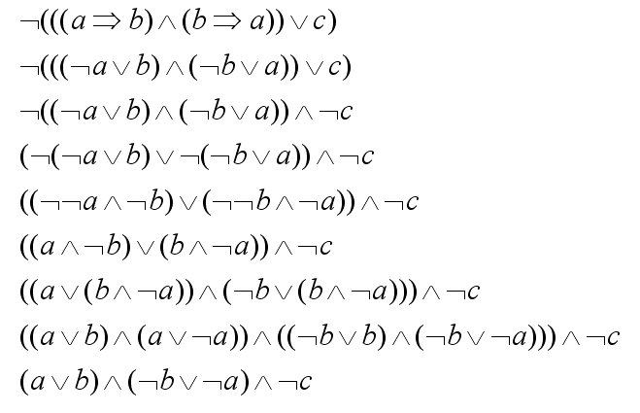

3. Which of the following are entailed by the sentence (A ∨ B) ^ (¬C ∨ ¬D ∨ E)?
i. (A ∨ B)
ii. (A ∨ B ∨ C) ^ (B ^ C ^ D ⇒ E)
iii. (A ∨ B) ^ (¬D ∨ E)

Solution

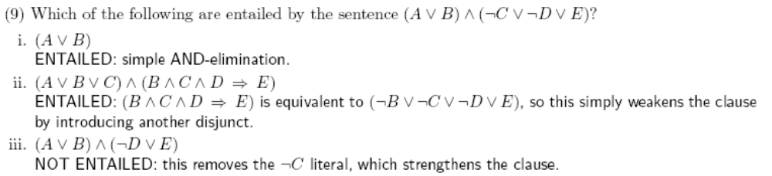

First order logic:
1. Which of the following is (are) correct translation of “Everyone’s zipcode within a state has the same first digit” to first order logic?
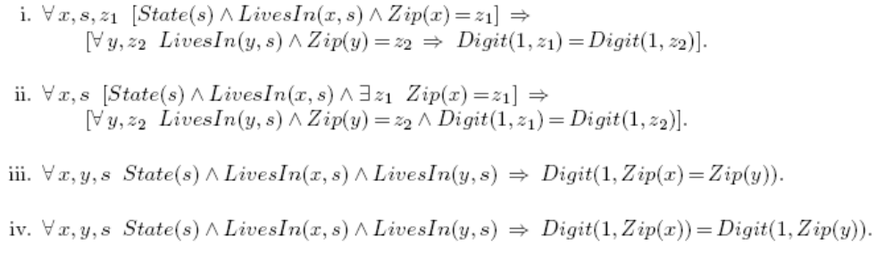

Solution:
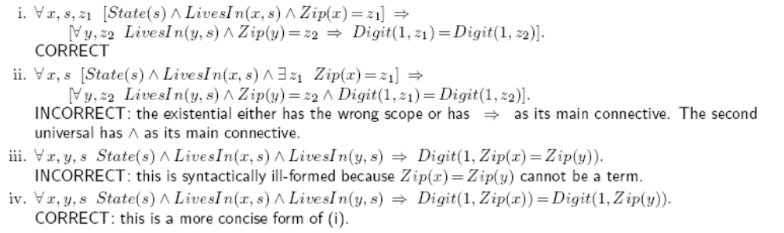

2. A complete representation of the rules of chess in propositional logic would be much larger than first-order logic. Which of the followings are valid reasons why?

i. The rules of chess are very complicated.
ii. A chess game can go on for hundreds of moves.
iii. There are several types of pieces.
iv. There are several pieces of each type.
v. There are 64 squares on the board.

Solution:
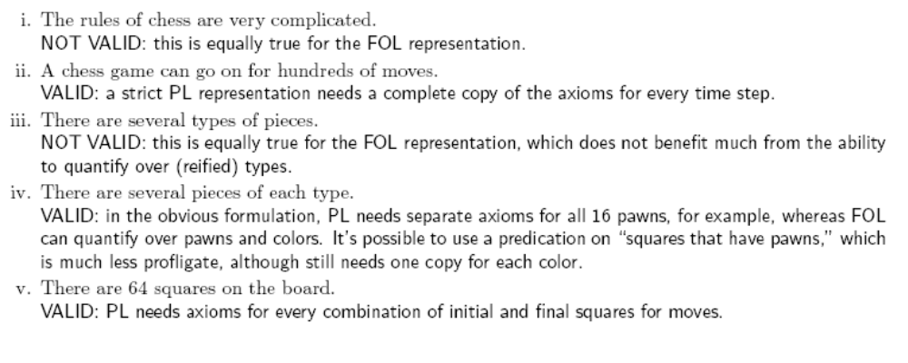

3. Translate into first order logic the sentence “Everyone’s DNA is unique and is derived from their parents’ DNA.” You must specify the precise intended meaning of your vocabulary terms. [Hint: do not use the predicate Unique(x), since uniqueness is not really a property of an object in itself!, relation can be between > objects]

Solution:
